**Experiment 2:-**Design an LED Chaser

**Circuit Diagram:-**

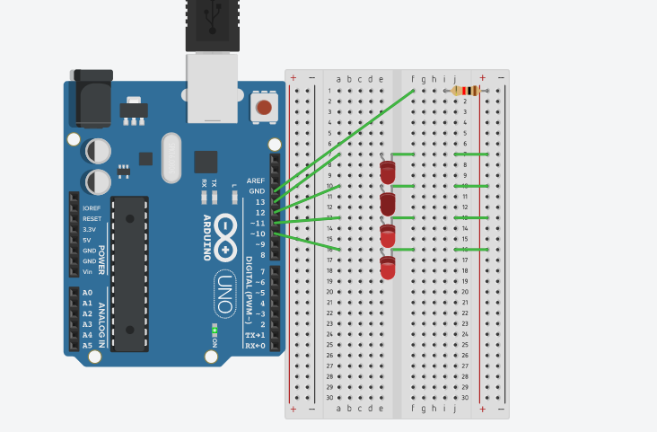

**Theory:-**

**Concept Used:-**

The concepts used by me to do this experiment are:-

* The arduino board can supply a power of 5v as digital output signals through the 14 pins (namely 0-13) present in it as digital input or output pins.
* The GND pin of the arduino board acts as ground.
* In the bread board present in the above circuit diagram the two rows present at the top and bottom each, are connected with each other in series and the columns present in between are connected in a set of 5 each. The connection pattern is shown below: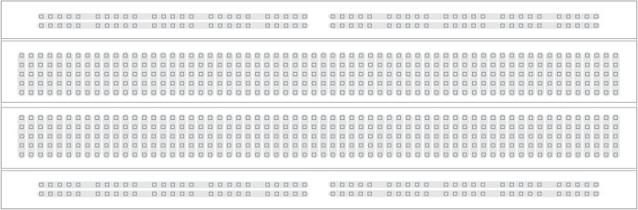
* In series crcuit voltage gets divided and in parallel circuit current gets divided.
* Kirchoff’s current law:-Total current flowing through a junction is equal to current flowing out of the junction.
* Ohm’s Law:-Ohm’s law states that the current through a conductor is directly proportional to the voltage across the two points provided that the physical conditions such as temperature remains constant.

V=IR

**Learning and Observation:-**

**Learning:-**

* By doing this experiment I have learned how to make a parallel circuit connection using an arduino board and a breadboard.
* I have also learned how to make pattern of different types using LED bulbs by providing different signals through arduino board.

**Observations:-**

* While doing this experiment I observed that first two LED glows and then the first LED goes off and the third one glows and a chain like this is formed and this pattern is a replication of the code that we have made for the arduino board to pass signals.

**Problems and Troubleshooting:-**

* The LEDs were not working properly so I had to replace them with new ones.
* The ends of the wire were not getting inserted properly in the holes of the breadboard so I had to make the ends of the wire straight first using a sand paper .
* The arduino board was not working .The cable connecting the arduino board was loose at one end so I had to replace the cable with another one.
* The required pattern was not getting created because of some error in the code so I had to change the code as per requirement.

**Precautions:-**

The precautions that we need to keep in mind while performing this experiment are:-

* The wires are inserted properly and tightly at the required points so that the circuit doesn’t get short.
* The two pins of the LED should be connected at their appropriate point that is the positive point should be connected with the p pin and the negative point should be connected with the negative pin.
* We should take care that the circuit is closed .

**Learning Outcomes:-**

* Through this experiment I have learned how to connect different hardware with an arduino board to form a parallel series.
* By doing this experiment I have gained the skill of making different kind of patterns of light using LEDs and arduino board.